**LAMPIRAN A**

**IMPLEMENTASI ANTARMUKA**

**Implementasi Anatarmuka**

* + - * 1. Antarmuka Login

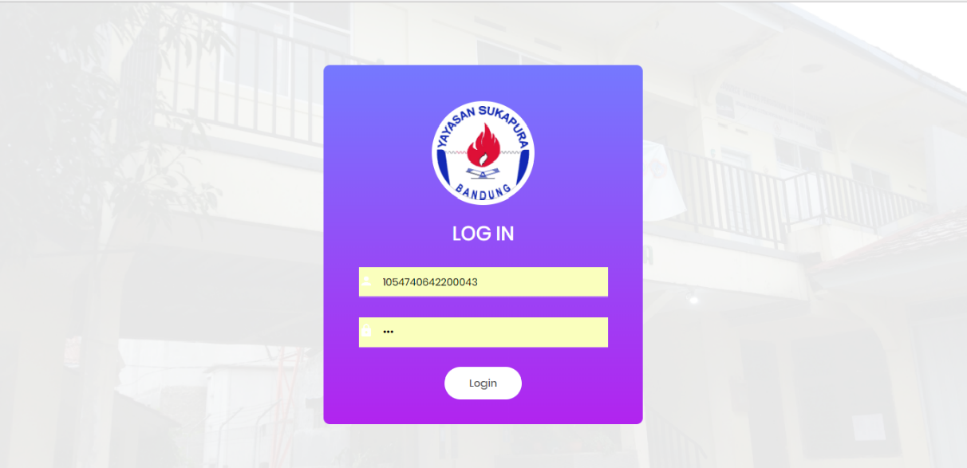

* + - * 1. Antarmuka Ubah Password

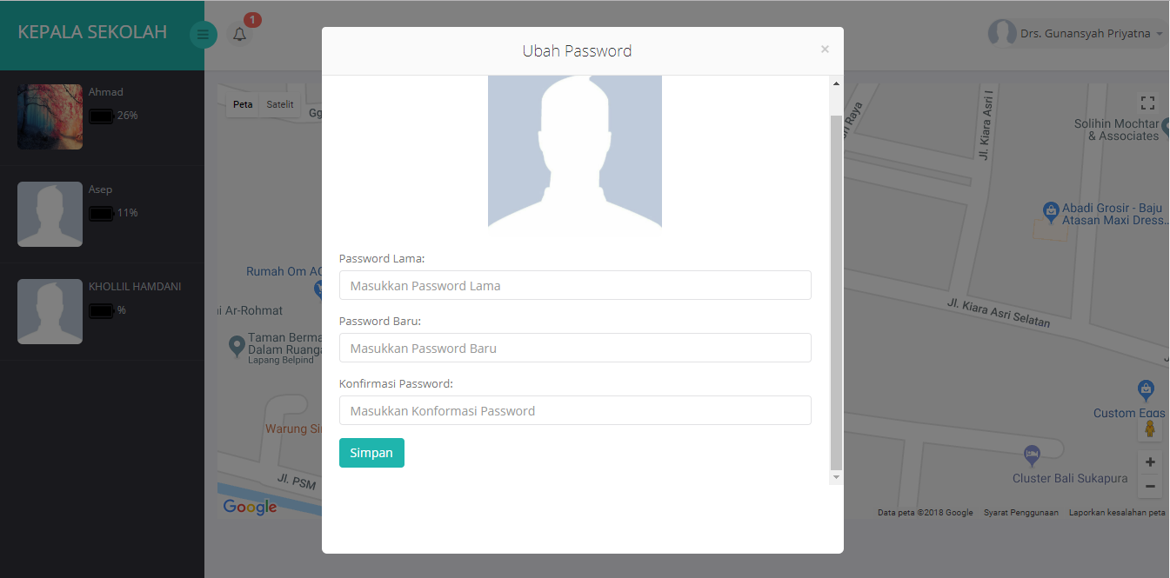

* + - * 1. Antarmuka Home Bagian Kesiswaan

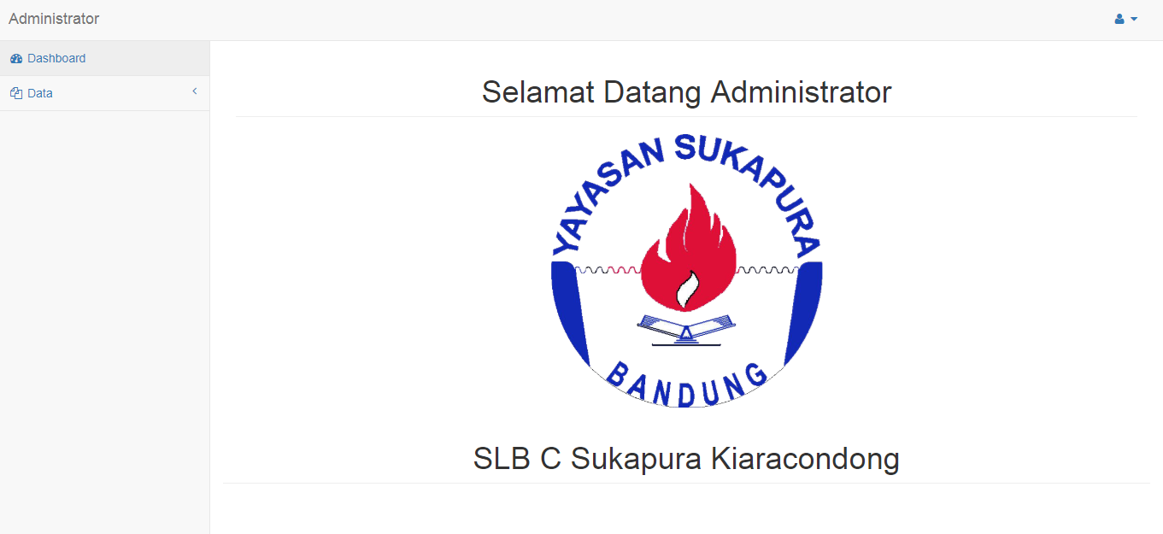

* + - * 1. Antarmuka Kelola Data Guru

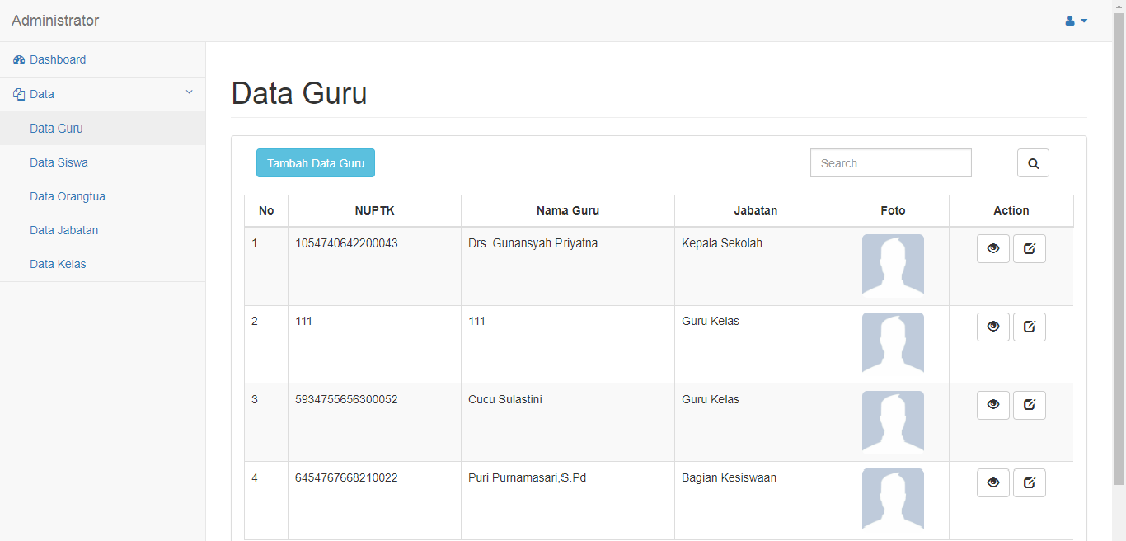

* + - * 1. Antarmuka Kelola Data Siswa

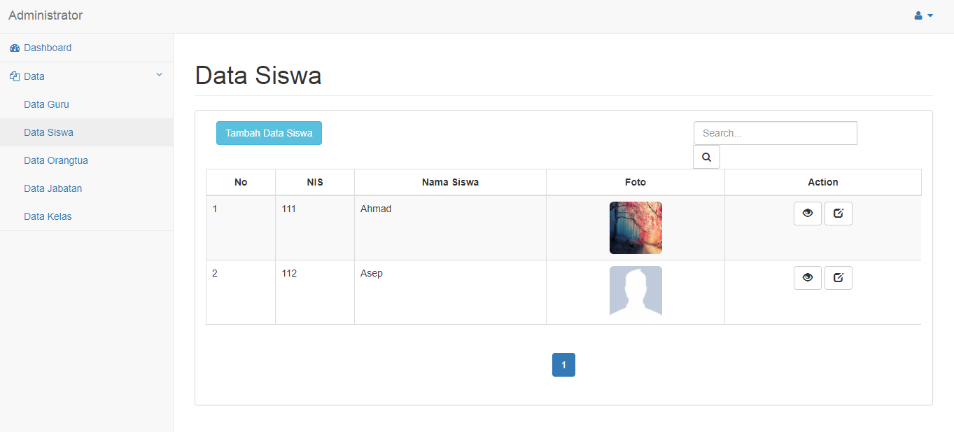

* + - * 1. Antarmuka Kelola Data Orangtua

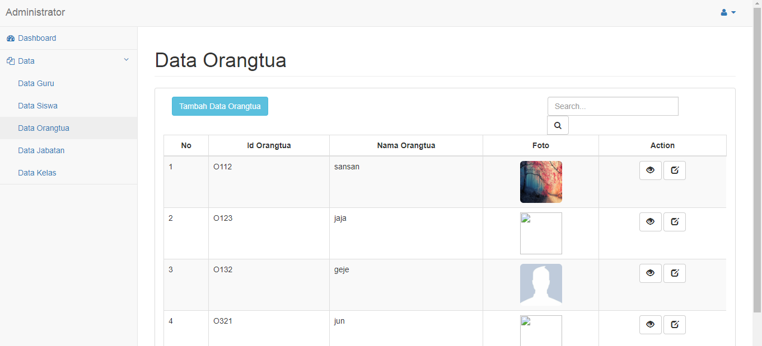

* + - * 1. Antarmuka Kelola Data Jabatan

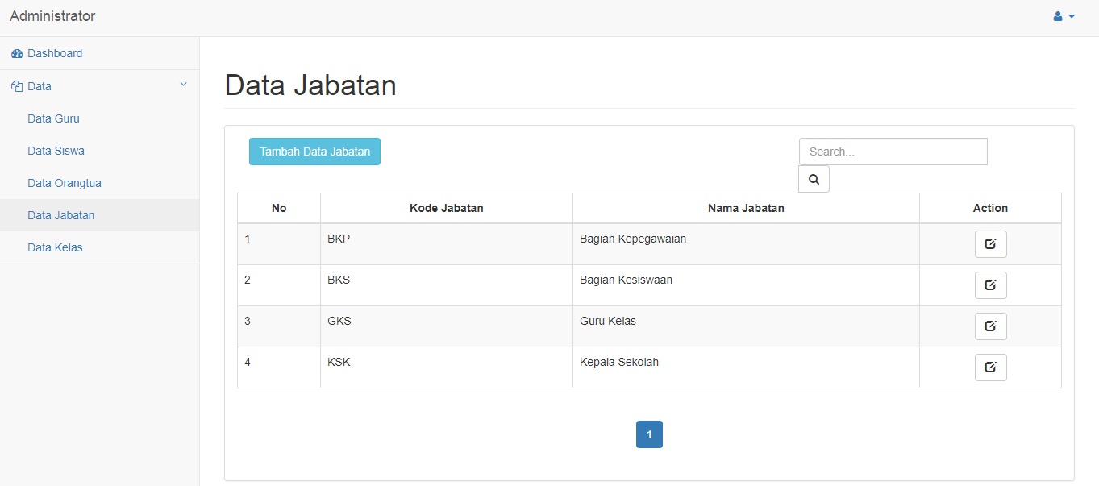

* + - * 1. Antarmuka Kelola Data Kelas

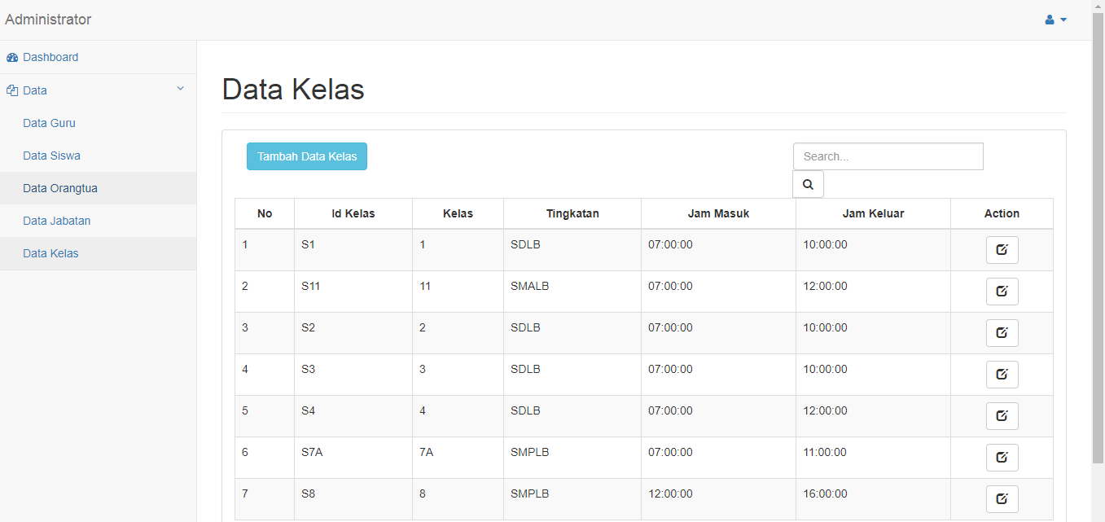

* + - * 1. Antarmuka Home Kepala Sekolah

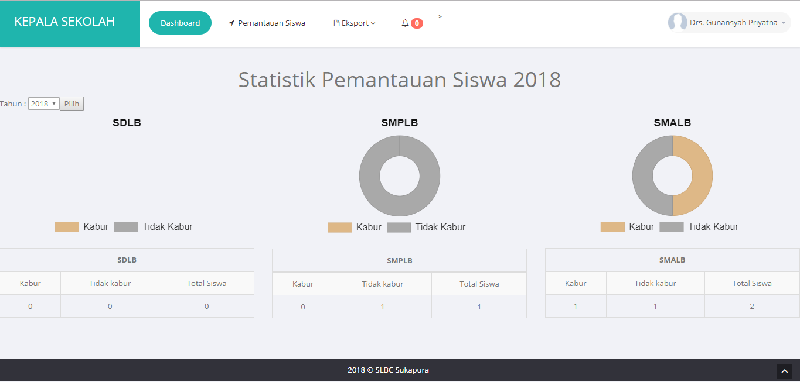

* + - * 1. Antarmuka Pemantauan Siswa (Kepala Sekolah)

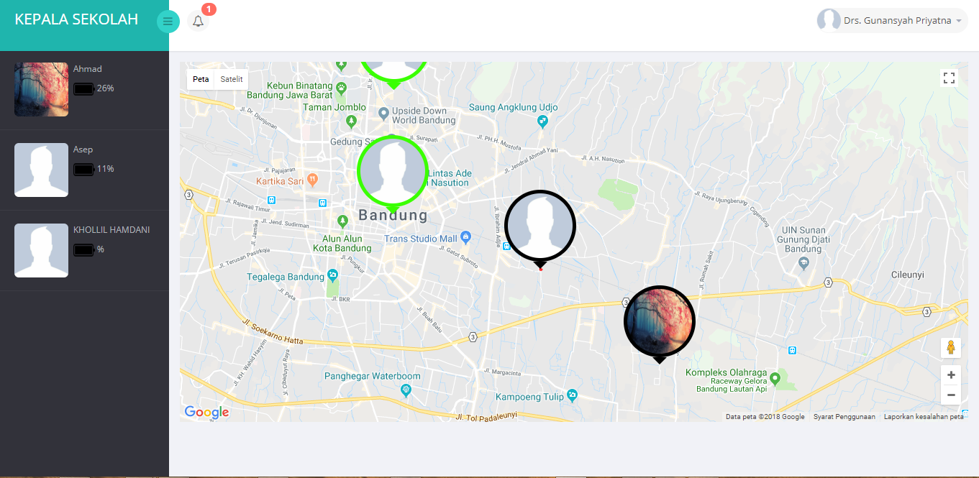

* + - * 1. Antarmuka Pemantauan Siswa (Guru)

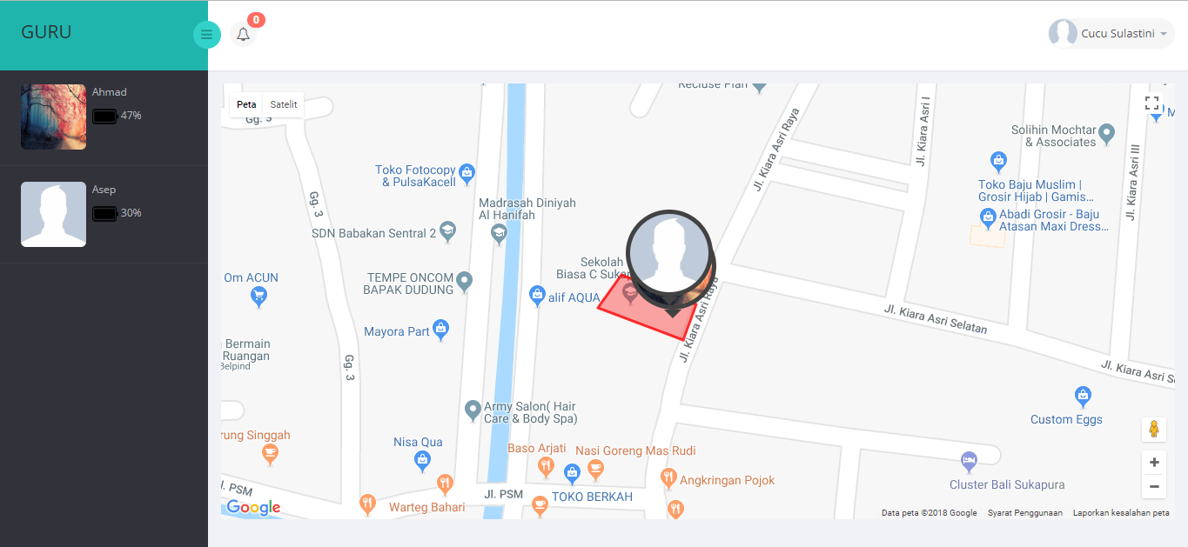

* + - * 1. Antarmuka Pemantauan Siswa (Orangtua)

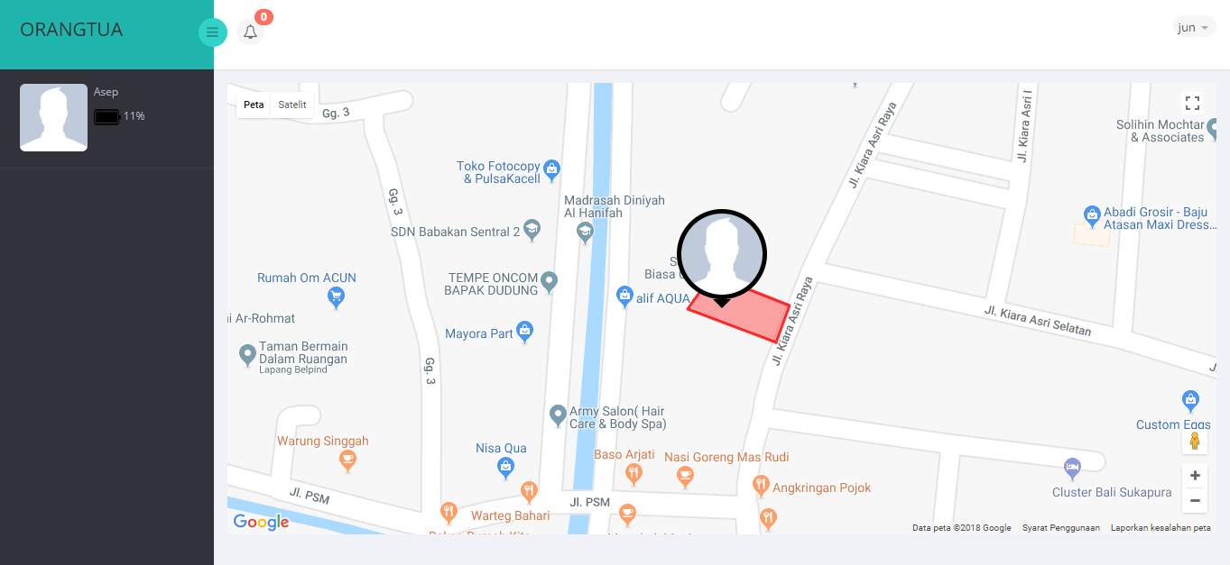

* + - * 1. Antarmuka lihat notifikasi (Orangtua)

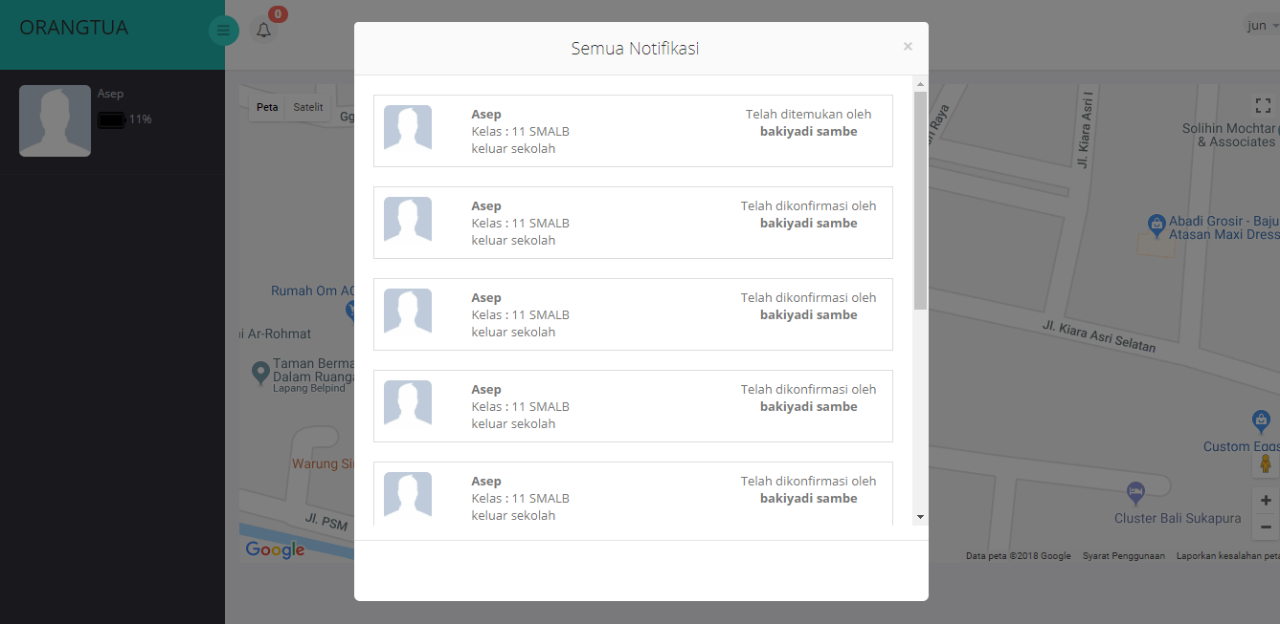

* + - * 1. Antarmuka lihat notifikasi (Guru/Kepala Sekolah)

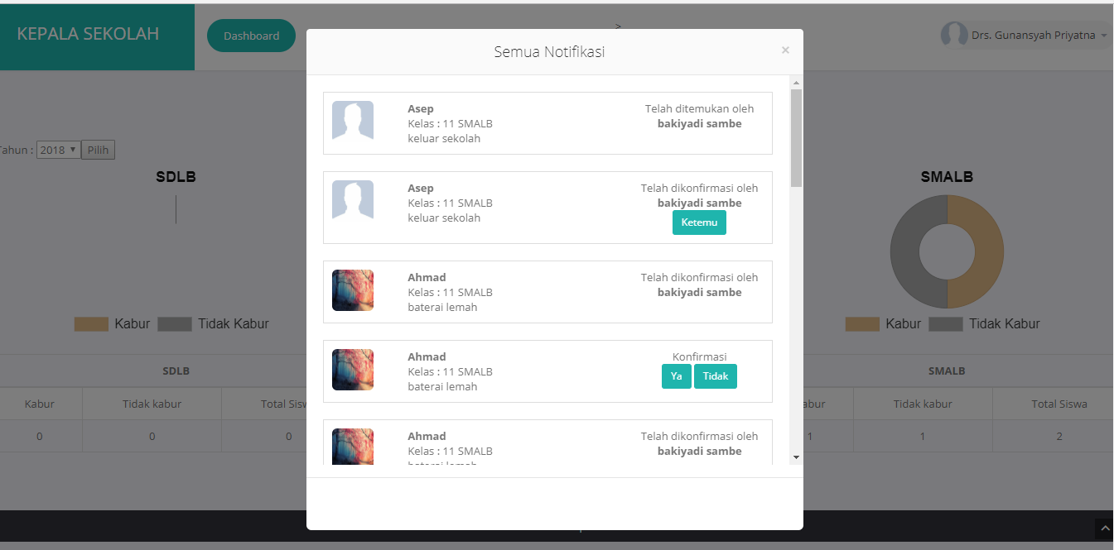

* + - * 1. Antarmuka lihat history lokasi siswa

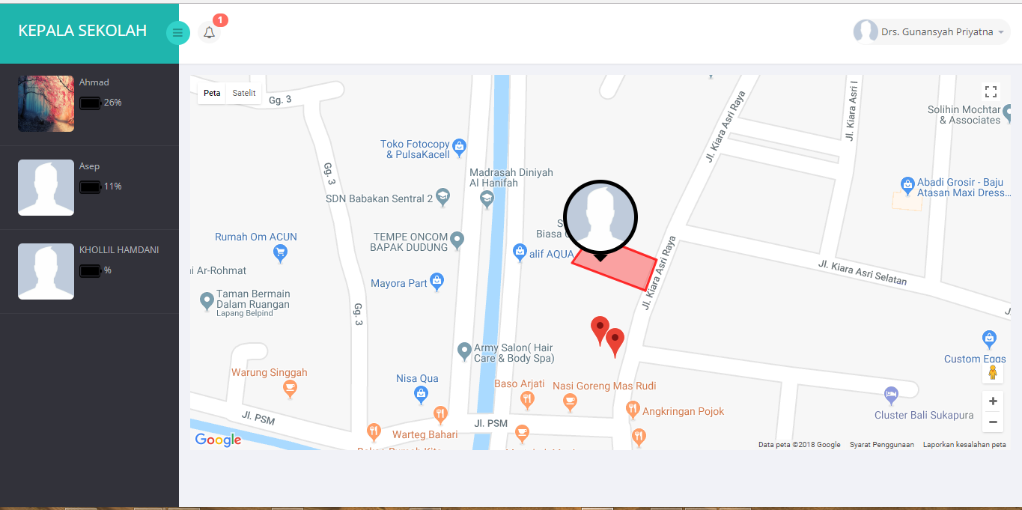

**LAMPIRAN B**

**LISTING PROGRAM**

**Listing Program**

**Index.php**

<?php

session_start();

$title = 'Login SLB C Sukapura Kota Bandung';

$halaman = 'login';

require( 'header.php' );

if ( isset( $_SESSION[ 's_pesan' ] ) ) {

?>

<div class="alert alert-warning" role="alert" align="center">

<strong>Warning! </strong>

<?php echo $_SESSION['s_pesan']; ?>

</div>

<?php

unset( $_SESSION[ 's_pesan' ] );

}

?>

<script type="text/javascript">

if (!('Notification' in window)) {

alert('This browser does not support desktop notification');

} else if (Notification.permission === 'granted') {

notify();

} else if (Notification.permission !== 'denied') {

Notification.requestPermission(function(permission) {

if (!('permission' in Notification)) {

Notification.permission = permission;

}

if (permission === 'granted') {

notify();

}

});

}

</script>

<?php

if(isset($_SESSION['s_nuptk'])){

if($_SESSION[ 's_kode_jabatan' ] == "BKS"){

echo( "<script> location.href ='admin/home_admin.php';</script>" );

}else if ($_SESSION[ 's_kode_jabatan' ] == "KSK") {

echo( "<script> location.href ='kepala_sekolah/home_kepsek.php';</script>" );

}else{

echo( "<script> location.href ='guru/home_guru.php';</script>" );

}

}else if(isset($_SESSION['s_id_orangtua'])){

echo( "<script> location.href ='orangtua/home_ortu.php';</script>" );

}else{

?>

<div class="limiter">

<div class="container-login100" style="background-image: url('images/background.jpg');">

<div class="wrap-login100">

<form class="login100-form validate-form" enctype="multipart/form-data" action="login.php" method="post">

<span class="login100-form-logo">

<img src="images/logo.png" width="144" height="144">

</span>

<span class="login100-form-title p-b-34 p-t-27">

Log in

</span>

<div class="wrap-input100 validate-input" data-validate="Enter username">

<input class="input100" type="text" name="username" placeholder="Username">

<span class="focus-input100" data-placeholder="&#xf207;"></span>

</div>

<div class="wrap-input100 validate-input" data-validate="Enter password">

<input class="input100" type="password" name="password" placeholder="Password">

<span class="focus-input100" data-placeholder="&#xf191;"></span>

</div>

<div class="container-login100-form-btn">

<button class="login100-form-btn">

Login

</button>

</div>

</form>

</div>

</div>

</div>

<div id="dropDownSelect1"></div>

<?php

}

require('footer.php');

?>

**Guru/home_guru.php**

<?php

session_start();

if ( isset( $_SESSION[ 's_nuptk' ] ) ) {

require "../koneksi.php";

$link = koneksi_db();

$title = 'Guru SLB C Sukapura Kota Bandung';

$halaman = 'guru';

require( '../header.php' );

if ( isset( $_SESSION[ 's_pesan' ] ) ) {

?>

<div class="alert alert-warning" role="alert" align="center">

<button type="button" class="close" data-dismiss="alert" aria-label="Close">

<span aria-hidden="true">×</span>

</button>

<?php echo $_SESSION['s_pesan']; ?>

</div>

<?php

unset( $_SESSION[ 's_pesan' ] );

}

?>

<style>

.customMarker {

position: absolute;

cursor: pointer;

background: #424242;

width: 100px;

height: 100px;

/* -width/2 */

margin-left: -50px;

/* -height + arrow */

margin-top: -110px;

border-radius: 50%;

padding: 0px;

}

.customMarker:after {

content: "";

position: absolute;

bottom: -10px;

left: 40px;

border-width: 10px 10px 0;

border-style: solid;

border-color: #424242 transparent;

display: block;

width: 0;

}

.customMarker img {

width: 90px;

height: 90px;

margin: 5px;

border-radius: 50%;

}

</style>

<script>

var refreshId = setInterval( function () {

$( '.responsecontainer' ).load( 'batre.php' );

}, 1000 );

$.ajax( {

type: 'post',

url: 'ajax.php',

data: {

fungsi : 'angka_badge'

},

dataType: "json",

success: function ( data ) {

$( '.angka-badge' ).html( data.jumlah );

}

} );

$.ajax( {

type: 'post',

url: 'ajax.php',

data: {

fungsi : 'notifikasi'

},

success: function ( data ) {

$( '.notif' ).html( data );

}

} );

</script>

<section id="container">

<!--header start-->

<header class="header fixed-top clearfix">

<!--logo start-->

<div class="brand">

<a href="index.html" class="logo">

GURU

</a>

<div class="sidebar-toggle-box">

<div class="fa fa-bars"></div>

</div>

</div>

<!--logo end-->

<div class="nav notify-row" id="top_menu">

<!-- notification start -->

<ul class="nav top-menu">

<!-- settings start -->

<!-- settings end -->

<!-- inbox dropdown start-->

<li id="header_inbox_bar" class="dropdown update-badge">

<a data-toggle="dropdown" class="dropdown-toggle" href="#">

<i class="fa fa-bell-o"></i>

<span class="badge bg-important angka-badge"></span>

</a>

<ul class="dropdown-menu extended inbox notif">

</ul>

<script>

$( document ).on( 'click', '.update-badge', function () {

//menampilkan jumlah status 1

$.ajax( {

type: 'post',

url: 'ajax.php',

data: {

fungsi : 'angka_badge',

command: 'update-badge'

},

dataType: "json",

success: function ( data ) {

$( '.angka-badge' ).html( data.jumlah );

}

} );

} );

</script>

</li>

<!-- notification dropdown end -->

</ul>

<!-- notification end -->

</div>

<div class="top-nav clearfix">

<!--search & user info start-->

<ul class="nav pull-right top-menu">

<!-- user login dropdown start-->

<li class="dropdown">

<a data-toggle="dropdown" class="dropdown-toggle" href="#">

<img alt="" src="../images/guru/<?php echo $_SESSION[ 's_foto' ]; ?>">

<span class="username"><?php echo $_SESSION[ 's_nama' ]; ?></span>

<b class="caret"></b>

</a>

<ul class="dropdown-menu extended logout">

<li><a href="#ubah_pw" id="custId" data-toggle="modal" data-id="<?php echo $_SESSION['s_nuptk'];?>"><i class="fa fa-cog"></i>Ubah Password</a>

</li>

<li><a href="../logout.php"><i class="fa fa-key"></i> Log Out</a>

</li>

</ul>

</li>

<!-- user login dropdown end -->

</ul>

<!--search & user info end-->

</div>

</header>

<!--header end-->

<aside>

<div id="sidebar" class="nav-collapse">

<!-- sidebar menu start-->

<div class="leftside-navigation">

<ul class="sidebar-menu responsecontainer" id="nav-accordion">

</ul>

</div>

<!-- sidebar menu end-->

</div>

</aside>

<!--sidebar end-->

<!--main content start-->

<section id="main-content">

<section class="wrapper">

<!-- page start-->

<div class="row">

<div class="col-sm-12">

<section class="panel">

<div id="map" style="width: pxpx; height: 501px"></div>

</section>

</div>

<script type="text/javascript">

//Popup dos markers

var infoWindow = null;

//Visibilitas peta harus bersifat global

var map = null;

//Ini adalah susunan global penanda yang ada di layar

var markersArray = [];

var guruMarkerArray = [];

var guruCircleArray = [];

/*

* Inisialisasi Google Maps API

*/

function initialize() {

if ( Notification . permission !== "granted" ) {

Notification . requestPermission();

} else {

<?php

$query_notif = "SELECT * FROM `tb_notifikasi` JOIN tb_siswa ON tb_notifikasi.nis=tb_siswa.nis";

$result_notif = mysqli_query($link,$query_notif);

while($data_notif = mysqli_fetch_array($result_notif)){

?>

var notifikasi = new Notification( "<?php echo $data_notif['nama']; ?>", {

icon: "../images/guru/<?php echo $data_notif['foto']; ?>",

body: "<?php echo $data_notif['pesan_notif']; ?>",

} );

setTimeout( function () {

notifikasi . close();

}, 5000 );

<?php

}

?>

}

$.ajax( {

type: 'post',

url: 'ajax.php',

data: {

fungsi : 'angka_badge'

},

dataType: "json",

success: function ( data ) {

$( '.angka-badge' ).html( data.jumlah );

}

} );

//Saya tidak akan menjelaskan yang jelas !!!

var myLatlng = new google.maps.LatLng( -6.930447, 107.654425 );

var myOptions = {

zoom: 19,

center: myLatlng,

mapTypeId: google.maps.MapTypeId.ROADMAP

}

map = new google.maps.Map( document.getElementById( "map" ),

myOptions );

var triangleCoords = [ {

lat: -6.930547,

lng: 107.654587

}, //kanan bawah

{

lat: -6.930447,

lng: 107.654325

}, ///kiri bawah

{

lat: -6.930347,

lng: 107.654395

}, //kiri atas

{

lat: -6.930437,

lng: 107.654628

} //kanan atas

];

// Construct the polygon.

var bermudaTriangle = new google.maps.Polygon( {

paths: triangleCoords,

strokeColor: '#FF0000',

strokeOpacity: 0.8,

strokeWeight: 3,

fillColor: '#FF0000',

fillOpacity: 0.35

} );

bermudaTriangle.setMap( map );

infoWindow = new google.maps.InfoWindow;

//Metode ini saya buat untuk melakukan pemuatan penanda pada peta

//Eksekusi segera !!!

updateMaps();

//Kami juga mendefinisikan eksekusi dengan interval waktu

window.setInterval( updateMaps, 10000 );

}

/*

* Metode yang menghapus hamparan dari penanda

*/

function CustomMarker( latlng, map, imageSrc ) {

this.latlng_ = latlng;

this.imageSrc = imageSrc;

// Once the LatLng and text are set, add the overlay to the map. This will

// trigger a call to panes_changed which should in turn call draw.

this.setMap( map );

}

CustomMarker.prototype = new google.maps.OverlayView();

CustomMarker.prototype.draw = function () {

// Check if the div has been created.

// alert(this.div_);

var div = this.div_;

if ( !div ) {

// Create a overlay text DIV

div = this.div_ = document.createElement( 'div' );

// Create the DIV representing our CustomMarker

div.className = "customMarker"

var img = document.createElement( "img" );

img.src = this.imageSrc;

div.appendChild( img );

google.maps.event.addDomListener( div, "click", function ( event ) {

google.maps.event.trigger( me, "click" );

} );

// Then add the overlay to the DOM

var panes = this.getPanes();

panes.overlayImage.appendChild( div );

}

// Position the overlay

var point = this.getProjection().fromLatLngToDivPixel( this.latlng_ );

if ( point ) {

div.style.left = point.x + 'px';

div.style.top = point.y + 'px';

}

};

CustomMarker.prototype.remove = function () {

// Check if the overlay was on the map and needs to be removed.

// this.div_.parentNode.removeChild( this.div_ );

// this.div_ = null;

if ( this.div_ ) {

this.div_.parentNode.removeChild( this.div_ );

this.div_ = null;

}

};

CustomMarker.prototype.getPosition = function () {

return this.latlng_;

};

function clearOverlays() {

for ( var i = 0; i < markersArray.length; i++ ) {

markersArray[ i ].setMap( null );

}

for ( var i = 0; i < guruMarkerArray.length; i++ ) {

guruMarkerArray[ i ].setMap( null );

}

for ( var i = 0; i < guruCircleArray.length; i++ ) {

guruCircleArray[ i ].setMap( null );

}

}

/*

* Metode yang memanggil jalur data xml

* dan memperbarui peta

*/

var i = 0;

function load_notification() {

$.ajax( {

type: 'post',

url: 'ajax.php',

data: {

fungsi : 'angka_badge'

},

dataType: "json",

success: function ( data ) {

$( '.angka-badge' ).html( data.jumlah );

}

} );

$.ajax( {

type: 'post',

url: 'ajax.php',

data: {

fungsi : 'notifikasi'

},

success: function ( data ) {

$( '.notif' ).html( data );

}

} );

}

function showPosition( position ) {

var myLatLngGuru = {

lat: position.coords.latitude,

lng: position.coords.longitude

};

var markerGuru = new google.maps.Marker( {

position: myLatLngGuru,

map: map,

title: 'ini guru'

} );

var guruCircle = new google.maps.Circle( {

strokeColor: '#FF0000',

strokeOpacity: 0.8,

strokeWeight: 2,

fillColor: '#FF0000',

fillOpacity: 0.35,

map: map,

center: {

lat: position.coords.latitude,

lng: position.coords.longitude

},

radius: 20

} );

guruMarkerArray.push( markerGuru );

guruCircleArray.push( guruCircle );

}

function updateMaps() {

if ( i != 0 ) {

clearOverlays();

} else {

i = i + 1;

}

navigator.geolocation.getCurrentPosition( showPosition );

var triangleCoords = [ {

lat: -6.930547,

lng: 107.654587

}, //kanan bawah

{

lat: -6.930447,

lng: 107.654325

}, ///kiri bawah

{

lat: -6.930347,

lng: 107.654395

}, //kiri atas

{

lat: -6.930437,

lng: 107.654628

} //kanan atas

];

var bermudaTriangle = new google.maps.Polygon( {

paths: triangleCoords,

strokeColor: '#FF0000',strokeOpacity: 0.8,

strokeWeight: 3,

fillColor: '#FF0000',

fillOpacity: 0.35

});

<?php

if(isset($_POST['nis'])){

$nis = $_POST['nis'];

?>

var timestamp = new Date().getTime();

var data = 'data.php?t=' + timestamp+'&nis='+<?php echo $nis; ?>;

//Me guardo o direito a não explicar o óbvio, novamente

$.get( data, {}, function ( data ) {

$( data ).find( "marker" ).each(

function () {

var marker = $( this );

var overlay = new CustomMarker( new google.maps.LatLng( parseFloat( marker.attr( "lat" ) ), parseFloat( marker.attr( "lng" ) ) ), map, "../images/siswa/" + marker.attr( "foto" ) );

var myLatlng = new google.maps.LatLng( marker.attr( "lat" ), marker.attr( "lng" ) );

var hasil = google.maps.geometry.poly.containsLocation( myLatlng, bermudaTriangle ) ? "didalam" : "diluar";

if ( hasil == "diluar" && marker.attr( "status" ) == 0 ) {

$.ajax( {

type: 'post',

url: 'ajax.php',

data: {

fungsi : 'update_notifikasi',

nis : marker.attr( "nis" ),

kelas : marker.attr( "kelas" ),

nama : marker.attr( "nama" ),

perintah : "0 jadi 2"

},

success: function ( data ) {

load_notification();

}

} );

} else if ( hasil == "didalam" && marker.attr( "status" ) == 2 ) {

$.ajax( {

type: 'post',

url: 'ajax.php',

data: {

fungsi : 'update_notifikasi',

nis: marker.attr( "nis" ),

kelas: marker.attr( "kelas" ),

nama: marker.attr( "nama" ),

perintah: "2 jadi 0"

},

success: function ( data ) {

load_notification();

}

} );

}

markersArray.push( overlay );

} );

} );

<?php

}

?>

var timestamp = new Date().getTime();

var data = 'data.php?t=' + timestamp;

//Me guardo o direito a não explicar o óbvio, novamente

$.get( data, {}, function ( data ) {

$( data ).find( "marker" ).each(

function () {

var marker = $( this );

var overlay = new CustomMarker( new google.maps.LatLng( parseFloat( marker.attr( "lat" ) ), parseFloat( marker.attr( "lng" ) ) ), map, "../images/siswa/" + marker.attr( "foto" ) );

var myLatlng = new google.maps.LatLng( marker.attr( "lat" ), marker.attr( "lng" ) );

var hasil = google.maps.geometry.poly.containsLocation( myLatlng, bermudaTriangle ) ? "didalam" : "diluar";

if ( hasil == "diluar" && marker.attr( "status" ) == 0 ) {

$.ajax( {

type: 'post',

url: 'ajax.php',

data: {

fungsi : 'update_notifikasi',

nis : marker.attr( "nis" ),

kelas : marker.attr( "kelas" ),

nama : marker.attr( "nama" ),

perintah : "0 jadi 2"

},

success: function ( data ) {

load_notification();

}

} );

} else if ( hasil == "didalam" && marker.attr( "status" ) == 2 ) {

$.ajax( {

type: 'post',

url: 'ajax.php',

data: {

fungsi : 'update_notifikasi',

nis: marker.attr( "nis" ),

kelas: marker.attr( "kelas" ),

nama: marker.attr( "nama" ),

perintah: "2 jadi 0"

},

success: function ( data ) {

load_notification();

}

} );

}

markersArray.push( overlay );

} );

} );

}

google.setOnLoadCallback( initialize );

</script>

</div>

<!-- page end-->

</section>

</section>

<div class="modal fade" id="ubah_pw" tabindex="-1" role="dialog" aria-labelledby="ubah" aria-hidden="true">

<div class="modal-dialog" role="document">

<!-- Modal content-->

<div class="modal-content">

<div class="modal-header">

<button type="button" class="close" data-dismiss="modal">&times;</button>

<center>

<h4 class="modal-title">Ubah Password</h4>

</center>

</div>

<div class="modal-body">

<div class="hasil-data"></div>

</div>

</div>

</div>

</div>

<!-- modal detail -->

<div class="modal fade" id="detail_siswa" tabindex="-1" role="dialog" aria-labelledby="detail" aria-hidden="true">

<div class="modal-dialog" role="document">

<!-- Modal content-->

<div class="modal-content">

<div class="modal-header">

<button type="button" class="close" data-dismiss="modal">&times;</button>

<center>

<h4 class="modal-title">Detail Siswa</h4>

</center>

</div>

<div class="modal-body">

<div class="hasil-data"></div>

</div>

</div>

</div>

</div>

</div>

<script type="text/javascript">

$( document ).on( 'click', '.konfirmasi', function () {

//menampilkan jumlah status 1

var nis_siswa = document.getElementById("nis").innerHTML;

var id_notifikasi = document.getElementById("id_notifikasi").innerHTML;

var waktu_keluar = document.getElementById("waktu_keluar").innerHTML;

$.ajax( {

type: 'post',

url: 'ajax.php',

data: {

fungsi : 'update_status_notifikasi',

command: "update-konfirmasi",

idNotifikasi: id_notifikasi,

nis: nis_siswa,

waktu: waktu_keluar

},

success: function ( data ) {

}

} );

} );

$( document ).on( 'click', '.ketemu', function () {

//menampilkan jumlah status 1

var id_notifikasi = document.getElementById("id_notifikasi").innerHTML;

var nis_siswa = document.getElementById("nis").innerHTML;

$.ajax( {

type: 'post',

url: 'ajax.php',

data: {

fungsi : 'update_status_notifikasi',

command: "update-ketemu",

idNotifikasi : id_notifikasi,

nis : nis_siswa

},

success: function ( data ) {

}

} );

} );

$( document ).ready( function () {

$( '#ubah_pw' ).on( 'show.bs.modal', function ( e ) {

var idx = $( e.relatedTarget ).data( 'id' ); //harus tetap id, jika tidak akan data tak akan terambil

//menggunakan fungsi ajax untuk pengambilan data

$.ajax( {

type: 'post',

url: 'ajax.php',

data: {

nuptk : idx,

fungsi : 'ubah_pw'

},

success: function ( data ) {

$( '.hasil-data' ).html( data ); //menampilkan data ke dalam modal

}

} );

} );

} );

$( document ).ready( function () {

$( '#detail_siswa' ).on( 'show.bs.modal', function ( e ) {

var idx = $( e.relatedTarget ).data( 'id' ); //harus tetap id, jika tidak akan data tak akan terambil

//menggunakan fungsi ajax untuk pengambilan data

$.ajax( {

type: 'post',

url: 'ajax.php',

data: {

nis : idx,

fungsi : 'detail_siswa'

},

success: function ( data ) {

$( '.hasil-data' ).html( data ); //menampilkan data ke dalam modal

}

} );

} );

} );

</script>

<!--main content end-->

<!--right sidebar start-->

<div class="right-sidebar">

<div class="search-row">

<input type="text" placeholder="Search" class="form-control">

</div>

<div class="right-stat-bar">

<ul class="right-side-accordion">

<li class="widget-collapsible">

<a href="#" class="head widget-head red-bg active clearfix">

<span class="pull-left">work progress (5)</span>

<span class="pull-right widget-collapse"><i class="ico-minus"></i></span>

</a>

<ul class="widget-container">

<li>

<div class="prog-row side-mini-stat clearfix">

<div class="side-graph-info">

<h4>Target sell</h4>

<p>

25%, Deadline 12 june 13

</p>

</div>

<div class="side-mini-graph">

<div class="target-sell">

</div>

</div>

</div>

<div class="prog-row side-mini-stat">

<div class="side-graph-info">

<h4>product delivery</h4>

<p>

55%, Deadline 12 june 13

</p>

</div>

<div class="side-mini-graph">

<div class="p-delivery">

<div class="sparkline" data-type="bar" data-resize="true" data-height="30" data-width="90%" data-bar-color="#39b7ab" data-bar-width="5" data-data="[200,135,667,333,526,996,564,123,890,564,455]">

</div>

</div>

</div>

</div>

<div class="prog-row side-mini-stat">

<div class="side-graph-info payment-info">

<h4>payment collection</h4>

<p>

25%, Deadline 12 june 13

</p>

</div>

<div class="side-mini-graph">

<div class="p-collection">

<span class="pc-epie-chart" data-percent="45">

<span class="percent"></span>

</span>

</div>

</div>

</div>

<div class="prog-row side-mini-stat">

<div class="side-graph-info">

<h4>delivery pending</h4>

<p>

44%, Deadline 12 june 13

</p>

</div>

<div class="side-mini-graph">

<div class="d-pending">

</div>

</div>

</div>

<div class="prog-row side-mini-stat">

<div class="col-md-12">

<h4>total progress</h4>

<p>

50%, Deadline 12 june 13

</p>

<div class="progress progress-xs mtop10">

<div style="width: 50%" aria-valuemax="100" aria-valuemin="0" aria-valuenow="20" role="progressbar" class="progress-bar progress-bar-info">

<span class="sr-only">50% Complete</span>

</div>

</div>

</div>

</div>

</li>

</ul>

</li>

<li class="widget-collapsible">

<a href="#" class="head widget-head terques-bg active clearfix">

<span class="pull-left">contact online (5)</span>

<span class="pull-right widget-collapse"><i class="ico-minus"></i></span>

</a>

<ul class="widget-container">

<li>

<div class="prog-row">

<div class="user-thumb">

</div>

<div class="user-details">

<h4><a href="#">Jonathan Smith</a></h4>

<p>

Work for fun

</p>

</div>

<div class="user-status text-danger">

<i class="fa fa-comments-o"></i>

</div>

</div>

<div class="prog-row">

<div class="user-thumb">

<a href="#"><img src="" alt=""></a>

</div>

<div class="user-details">

<h4><a href="#">Anjelina Joe</a></h4>

<p>

Available

</p>

</div>

<div class="user-status text-success">

<i class="fa fa-comments-o"></i>

</div>

</div>

<div class="prog-row">

<div class="user-thumb">

<a href="#"><img src="" alt=""></a>

</div>

<div class="user-details">

<h4><a href="#">John Doe</a></h4>

<p>

Away from Desk

</p>

</div>

<div class="user-status text-warning">

<i class="fa fa-comments-o"></i>

</div>

</div>

<div class="prog-row">

<div class="user-thumb">

<a href="#"><img src="" alt=""></a>

</div>

<div class="user-details">

<h4><a href="#">Mark Henry</a></h4>

<p>

working

</p>

</div>

<div class="user-status text-info">

<i class="fa fa-comments-o"></i>

</div>

</div>

<div class="prog-row">

<div class="user-thumb">

<a href="#"><img src="" alt=""></a>

</div>

<div class="user-details">

<h4><a href="#">Shila Jones</a></h4>

<p>

Work for fun

</p>

</div>

<div class="user-status text-danger">

<i class="fa fa-comments-o"></i>

</div>

</div>

<p class="text-center">

<a href="#" class="view-btn">View all Contacts</a>

</p>

</li>

</ul>

</li>

<li class="widget-collapsible">

<a href="#" class="head widget-head purple-bg active">

<span class="pull-left"> recent activity (3)</span>

<span class="pull-right widget-collapse"><i class="ico-minus"></i></span>

</a>

<ul class="widget-container">

<li>

<div class="prog-row">

<div class="user-thumb rsn-activity">

<i class="fa fa-clock-o"></i>

</div>

<div class="rsn-details ">

<p class="text-muted">

just now

</p>

<p>

<a href="#">Jim Doe </a>Purchased new equipments for zonal office setup

</p>

</div>

</div>

<div class="prog-row">

<div class="user-thumb rsn-activity">

<i class="fa fa-clock-o"></i>

</div>

<div class="rsn-details ">

<p class="text-muted">

2 min ago

</p>

<p>

<a href="#">Jane Doe </a>Purchased new equipments for zonal office setup

</p>

</div>

</div>

<div class="prog-row">

<div class="user-thumb rsn-activity">

<i class="fa fa-clock-o"></i>

</div>

<div class="rsn-details ">

<p class="text-muted">

1 day ago

</p>

<p>

<a href="#">Jim Doe </a>Purchased new equipments for zonal office setup

</p>

</div>

</div>

</li>

</ul>

</li>

<li class="widget-collapsible">

<a href="#" class="head widget-head yellow-bg active">

<span class="pull-left"> shipment status</span>

<span class="pull-right widget-collapse"><i class="ico-minus"></i></span>

</a>

<ul class="widget-container">

<li>

<div class="col-md-12">

<div class="prog-row">

<p>

Full sleeve baby wear (SL: 17665)

</p>

<div class="progress progress-xs mtop10">

<div class="progress-bar progress-bar-success" role="progressbar" aria-valuenow="20" aria-valuemin="0" aria-valuemax="100" style="width: 40%">

<span class="sr-only">40% Complete</span>

</div>

</div>

</div>

<div class="prog-row">

<p>

Full sleeve baby wear (SL: 17665)

</p>

<div class="progress progress-xs mtop10">

<div class="progress-bar progress-bar-info" role="progressbar" aria-valuenow="20" aria-valuemin="0" aria-valuemax="100" style="width: 70%">

<span class="sr-only">70% Completed</span>

</div>

</div>

</div>

</div>

</li>

</ul>

</li>

</ul>

</div>

</div>

<!--right sidebar end-->

</section>

<?php

require( '../footer.php' );

} else {

echo( "<script> location.href ='../index.php';</script>" );

}

?>

**LAMPIRAN C**

**HASIL WAWANCARA DAN KUISIONER**

**Hasil Wawancara dan Kuisioner**

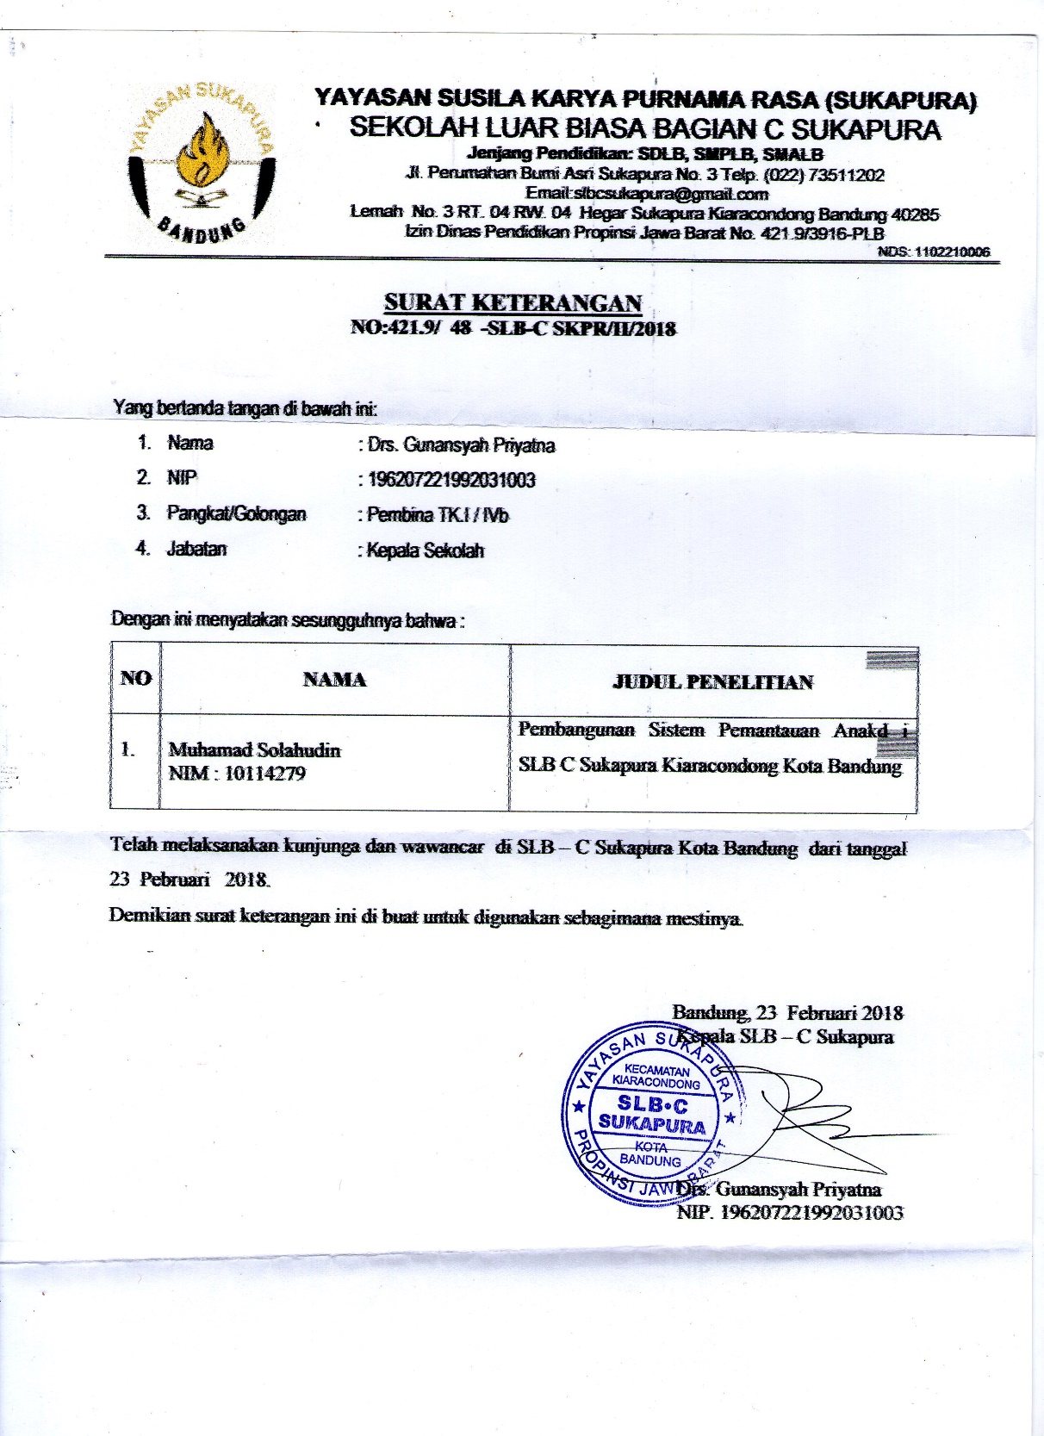

**LAMPIRAN D**

**KELENGKAPAN SURAT PENELITIAN**

**Kelengkapan Surat Penelitian**

